Interdisciplinary Unit
Kindergarten Unit 1
2015-2016

Concept: Observation

Essential Question: How do my observations affect how I make sense of the world?

Deepening Questions:
What are the different rules in my classroom, school and community?
Why is it important to observe rules?
How do we use our five senses to help gather information?
How do the five senses work together?
What words can I use to describe an object?
How can groups be sorted into groups by attributes?
What are the steps in the scientific method?
What is counting and how can it be used?
How do we use numbers to show an amount?

Suggested Trade Book Resources:
The Button Box by Margarette S. Reid
The 5 Senses (Let's Learn About) by Nuria Roca
The Listening Walk by Paul Showers (Lexile: 480, GR: I)
You Can't Taste a Pickle With Your Ear Hardcover by Harriet Ziefert (GR: O)
The Popcorn Book by Tomie dePaola (Lexile: 830, GR: N)
Seven Blind Mice by Ed Young (Lexile: 350, GR: K)
I am Helen Keller (Ordinary People Change World) by Brad Meltzer (Lexile: 460, GR: N)
Brown Bear, Brown Bear by Eric Carle (Lexile: 440, GR: C)
All the Colors of the Rainbow by Allan Fowler (Lexile: 670, GR: I)
Press Here by Herve Tullet
What Is Science? by Rebecca Kai Dotlich (Lexile: 350)
I Use Science Tools (My First Science Library K-1) by Kelli Hicks (Lexile: 490)
Splish, Splash, Splat! (Splat the Cat) by Rob Scotton (Lexile: 450)
David Goes to School by David Shannon (GR: G)
Pete the Cat: Rocking in My School Shoes by James Dean (Lexile: 600, GR: K)
Manners at School (Way To Be!: Manners) by Carrie Finn (Lexile: 520)
Pete the Cat and His Four Groovy Buttons by James Dean (Lexile: 350, GR: J)
Click, Clack, Splish, Splash by Doreen Cronin (Lexile: 300, GR: G)
Ten Black Dots by Donald Crews (Lexile: 270, GR: I)

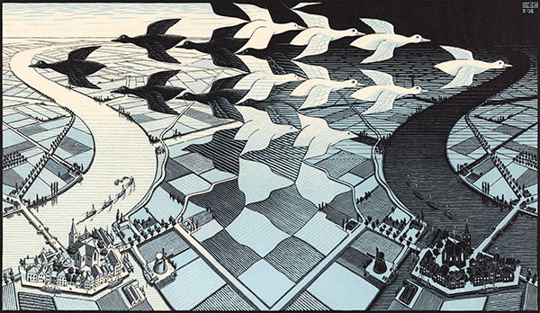
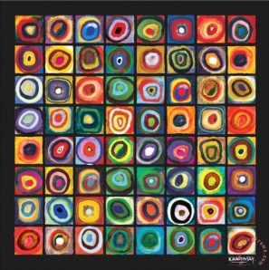
Hook:
Squares in Color of Squares, by Wassily Kadinsky
Day and Night, M.C. Escher

Looking at the two pieces of art, students can add questions/comments using a Wow/Wonder Chart
Prompt students to give Wows and Wonders that include ideas such as same/different, pattern/repetition, and colors (light/dark, mood).

Students can complete a short reflection journal entry picking their favorite from the two pieces of art explaining their choice.

Section 1: Observing Rules and Laws
States: all
Deepening Questions:
What are the different rules in my classroom, school and community?
Why is it important to observe rules?

    - Read David Goes to School by David Shannon
    - Back to School-David Goes to School (attachment)
- What are rules?
  - Who’s Who in our Classroom?
  - PERFORMANCE TASK: Narrative- (caption) My friend’s name is ___________. Students will illustrate a picture of themselves with someone in the classroom (pair up students.) They will add a caption under the picture.
  - Who’s Who in Our School?
    - Finding the Office close reading passage (attachment)
    - Pete the Cat school tour: (TPT $3): https://www.teacherspayteachers.com/Product/Pete-the-Cat-School-Tour-825180
  - Good Choices/Bad Choices
    - Read Pete the Cat: Rockin in My School Shoes by James Dean,
    - Pete the cat activities: (TPT $2.50) https://www.teacherspayteachers.com/Product/The-Groovy-Cat-School-Rule-Choices-Pocket-Chart-Activity-782474

  - Classroom Rules and Responsibilities
      - Caring for our classroom tools: http://www.kindergartenkindergarten.com/2011/08/teaching-rules-and-routines-more-glue-and-markers.html
  - School Rules and Responsibilities
      - Practicing school rules (attachment)
      - Jon follow school rules close reading passage (attachment)
    - Following rules (why)
      - Who is a good citizen at school close reading passage (attachment)
    - Consequences
  - Community Rules and Responsibilities
    - Safety Signs

- Using Manners
    - Read Manners at School (Way To Be!: Manners) by Carrie Finn
- Working Together
  - Respect
  - Sharing
  - Taking Turns
  - Helping others
    - Helping a Friend close reading passage (attachment)
- Solving a Problem

Section 2: Early Scientists (Simple Scientific Method)
A Closer Look: Be a Scientist (section is located at the very beginning of the TE)
- Five Senses
    - Five Senses Stem Unit (attachment)
    - Read The 5 Senses (Let's Learn About) by Nuria Roca
  - Identifying five senses
    - Five Senses video and game: Learning about each sense
    - Emergent Reader: http://www.makinglearningfun.com/themepages/FiveSenseBeeEmergentReader.htm
  - Senses and their Body Part
    - My Five Senses Labeling (attachment)
  - Learning about each sense
      - Your Five Senses close reading passage (attachment)
      - My Five Senses Freebies (attachment)
      - Five Senses Sort (attachment)
      - Pic Collage app activity: http://ksespreksprouts.blogspot.com/2014/03/five-senses-2-week-stem-unit.html
    - Hear
      - Read The Listening Walk by Paul Showers
      - Go on a nature walk and make a chart of all the sounds you heard and what made that noise
    - Taste
      - Read You Can't Taste a Pickle With Your Ear Hardcover by Harriet Ziefert
      - Taste Detective (attachment)
    - Touch
    - Smell
    - See
  - Investigating using five senses
      - Five Senses (TPT $8): https://www.teacherspayteachers.com/Product/Five-Senses-271580
    - Plan a set of centers or activities where students can explore each of the five senses and record their observations.
      - Read “The Popcorn Book” by Tomie dePaola
      - 4 Senses Investigation: Popcorn (attachment)
  - Why we need all 5 sense
    - Read Seven Blind Mice by Ed Young
  - When people lose their senses (blind, deaf, etc.)
    - Read I am Helen Keller (Ordinary People Change World) by Brad Meltzer
    - Read The Black Book of Colors and have students create pictures using black paper and Elmer’s glue. Here are some ideas: http://msnovak.blogspot.com/2012/01/black-book-of-colors-3rd-grade.html
    - Sign language
  - Categories of attributes
    - Texture
    - Size and shape (brief-will be covered in more detail in unit 5 and 6)
    - Colors
      - Color Names:
        - Color pals activities (attachment)
      - Brown Bear, Brown Bear by Eric Carle
        - Color Unit (TPT $6): Brown Bear, Brown Bear by Eric Carle
      - All the Colors of the Rainbow by Allan Fowler

      - All the Colors of the Rainbow by Allan Fowler
  - Describing objects
      - Attribute game
    - Dog’s Colorful Day by Emma Dodd
      - Practice describing colored things by color and name (red apple.)
      - More activities: http://www.makinglearningfun.com/themepages/DogsColorfulDay.htm
  - Sorting by attributes
    - Read The Button Box by Margarette S. Reid
      - Sorting different balls by attributes: http://www.kindergartenkindergarten.com/2010/07/math-problemsolving-week-3-attributes-and-sorting.html
  - PERFORMANCE TASK: Narrative-My ball is __________ and ___________. Take a digital picture of a ball the student selects from the ball basket (see above) and have students add a caption to the picture.

- Scientific Method
    - Scientific Method Kindergarten Style (attachment)
  - Using science tools
    - Plan activities where students get to “observe” with different kinds of scientific tools (magnifiying glass, balance, ruler or non-standard measurement objects,
  - Sink or Float
      - http://kinder-pond.blogspot.com/2012/11/the-scientific-method.html
    - Students will learn about the steps of the scientific method
      - Read Splish, Splash, Splat! (Splat the Cat) by Rob Scotton
      - Sink or float emergent reader: http://www.makinglearningfun.com/themepages/SinkandFloatEmergentReader.htm
      - Will it Float? Activity (attachment)

Section 3: Using Numbers
*This section may not be connected to the overall unit of “Observation.” Possible connections can relate to counting things when observing, etc.
States: all

Deepening Questions:
What is counting and how can it be used?
How do we use numbers to show an amount?

- Numbers to 5
  - Count 1, 2, and 3
  - Read and Write 1, 2, and 3
  - Count 4 and 5
  - Read and Write 4 and 5
    - Apple Counting Write the Room (attachment)
    - Math Dots 1-5 (attachment)
    - Number Bingo 0-5 (attachment)
  - Read and Write Zero
  - Equal to
  - Greater Than
  - Less Than
  - Compare Numbers 0 to 5
  - One More
    - Kindergarten numbers (attachment)
  - Draw a Diagram: Problem Solving Strategy

- Numbers to 10
  - Number 6 and 7
  - Number 8
  - Read and Write 6, 7, and 8
  - Number 9
  - Number 10
    - School Bus Count and Clip (attachment)
  - Read and Write 9 and 10
  - Act It Out: Problem Solving Strategy
  - Compare Numbers 0-10
  - One More with Numbers to 10
  - Ordinal Numbers to Fifth
  - Ordinal Numbers to Tenth

